**Features of Java**

Features of a language are nothing but the set of services or facilities provided by the language vendors to the industry programmers. Some important **features of java** are;

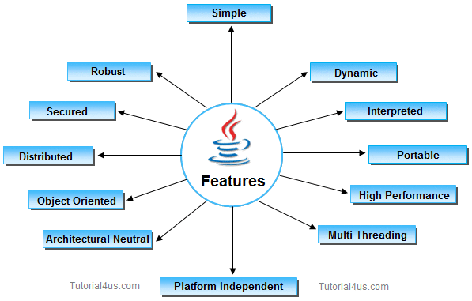

**Important Features of Java**

* Simple
* Platform Independent
* Architectural Neutral
* Portable
* Multi Threading
* Distributed
* Networked
* Robust
* Dynamic
* Secured
* High Performance
* Interpreted
* Object Oriented

**1. Simple**

**It is simple because of the following factors:**

* It is **free from pointer** due to this execution time of application is improved. [Whenever we write a Java program without pointers then internally it is converted into the equivalent pointer program].
* It has **Rich set of API** (application protocol interface).
* It hs **Garbage Collector** which is always used to collect un-Referenced (unused) Memory location for improving performance of a Java program.
* It contains user friendly syntax for developing any applications.

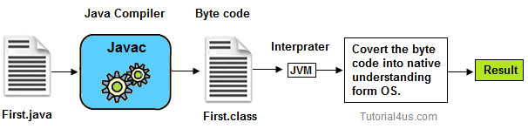

**2. Platform Independent**

A program or technology is said to be platform independent if and only if which can run on all available operating systems with respect to its development and compilation. (Platform represents O.S).

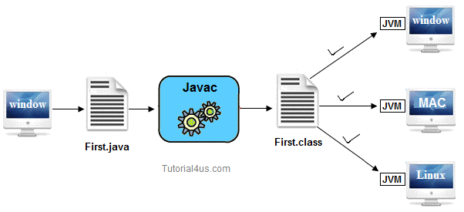

**3. Architectural Neutral**

Architecture represents processor.

A Language or Technology is said to be Architectural neutral which can run on any available processors in the real world without considering their apingitecturarchitecture (providers) irrearchitecture development and compilation.

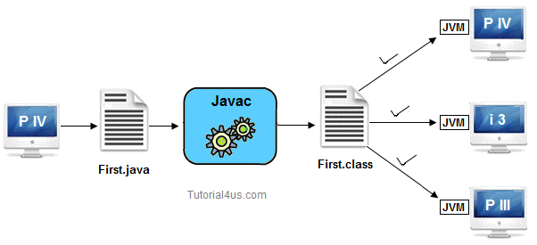

The languages like C, CPP are treated as architectural dependent.

**4. Portable**

If any language supports platform independent and architectural neutral feature known as portable. The languages like C, CPP, Pascal are treated as non-portable language. It is a portable language.  
According to SUN microsystem.

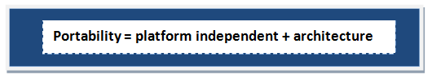

**5. Multithreaded**

A flow of control is known as a threa. When any Language executes multile thread at a time that language is known as multithreaded e. It is multithreaded.

**6. Distributed**

Using this language we can create distributed applications. RMI and EJB are used for creating distributed applications. In distributed application multiple client system depends on multiple server systems so that even problem occurred in one server will never be reflected on any client system.

**Note:**In this architecture same application is distributed in multiple server system.

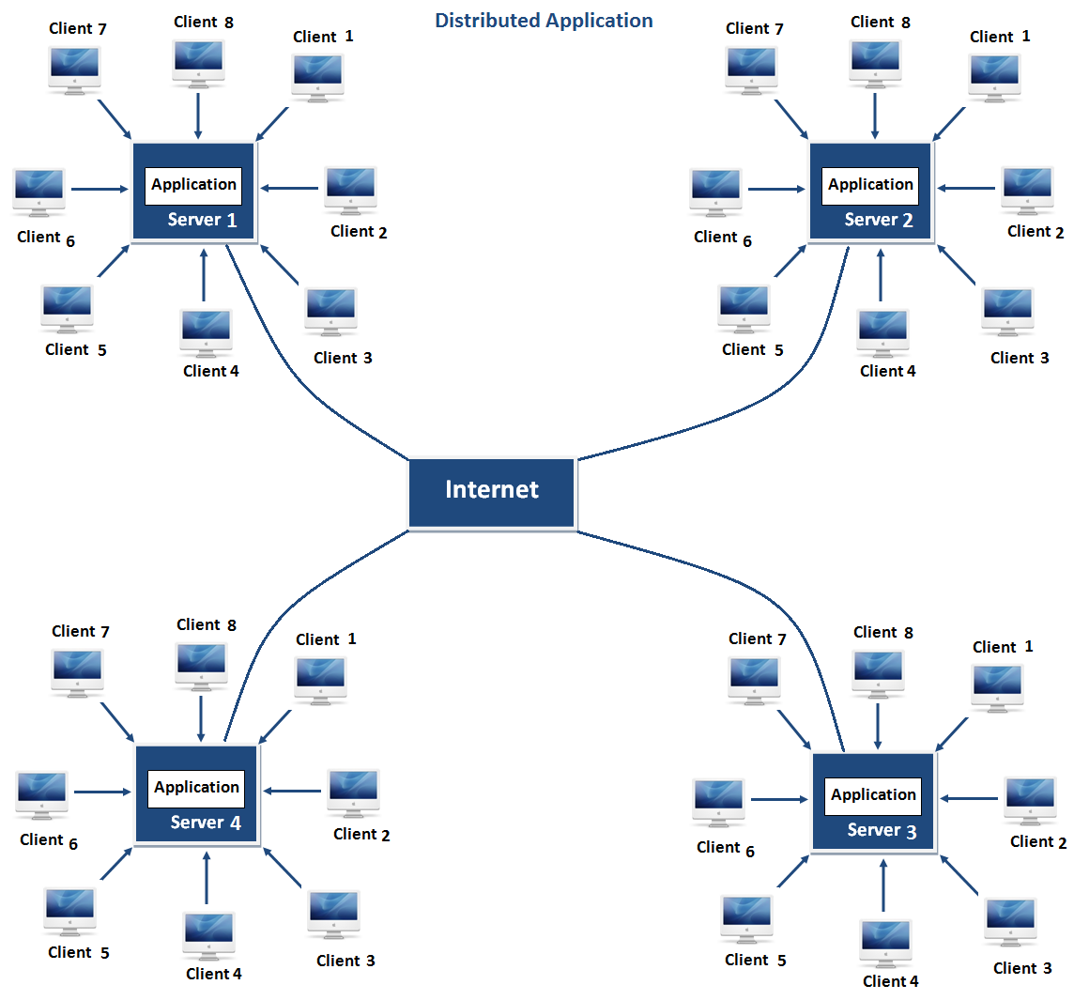

**7. Networked**

It is mainly designed for web based applications, J2EE is used for developing network based applications.

**8. Robust**

Simply means of Robust are strong. It is robust or strong Programming Language because of its capability to handle Run-time Error, automatic garbage collection, the lack of pointer concept, Exception Handling. All these points make It robust Language.

**9. Dynamic**

It supports Dynamic memory allocation due to this memory wastage is reduce and improve performance of the application. The process of allocating the memory space to the input of the program at a run-time is known as dynamic memory allocation, To programming to allocate memory space by dynamically we use an operator called 'new' 'new' operator is known as dynamic memory allocation operator.

**10. Secure**

It is a more secure language compared to other language; In this language, all code is covered in byte code after compilation which is not readable by human.

**11. High performance**

It have high performance because of following reasons;

* This language **uses Bytecode** which is faster than ordinary pointer code so Performance of this language is high.
* **Garbage collector**, collect the unused memory space and improve the performance of the application.
* It has **no pointers** so that using this language we can develop an application very easily.
* It **support multithreading**, because of this time consuming process can be reduced to executing the program.

**12. Interpreted**

It is one of the highly interpreted programming languages.

**13. Object Oriented**

It supports OOP's concepts because of this it is most secure language, for this topic you can read our oop's concepts in detail.